Individual Project – Project Proposal 2019-2020

Numerical Modelling of Thermal Management Systems for Lithium-ion Batteries

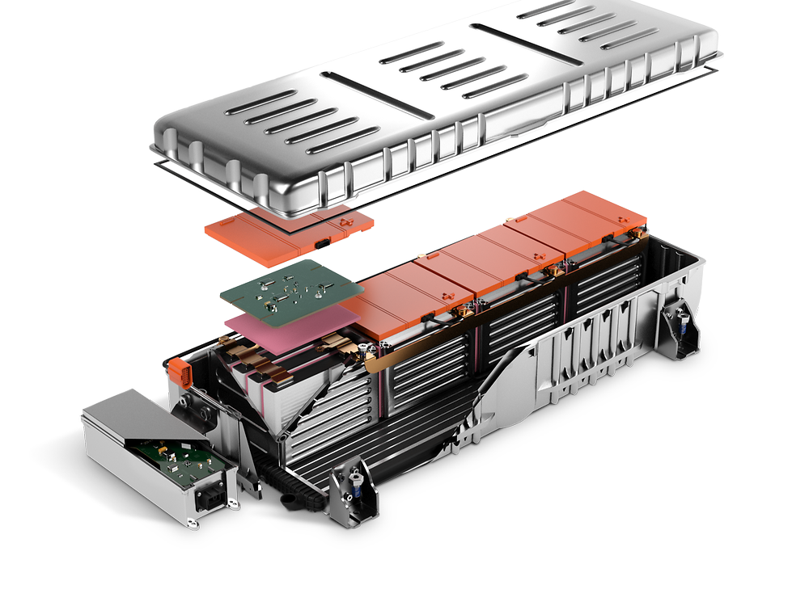

Omar Elsewify 10189937

TABLE OF CONTENTS

Abstract 2

Introduction 3

Project Background 3

Historical Context of Project 3

Current Problems Facing the EDV Industry 4

Aims and Objectives 5

Research Questions 5

Project Impact 5

Methodology and Research Design 7

Data Collection and Analysis 7

Description of Methodology 7

Numerical Simulation Theory 9

Modelling and Simulation Theory 9

Heat Transfer Theory 10

Literature Review 11

Current Context of Project 11

Description of Current Thermal Management Systems 12

Gaps in Literature 14

Proposed Work 16

Focus of this project 16

Initial work conducted 16

Stage 1 16

Stage 2 17

Stage 3 – Future Adjustments 17

Model Validation 18

Management of Project to Date and Future Plan 20

First Semester 20

Second Semester 20

Other courses’ deadlines 20

Appendices 21

Appendix 1: MATLAB Numerical model code 21

Appendix 2: GetID function 24

Appendix 3: MATLAB Testing Schedule code 24

Bibliography 26

# Abstract

As the automotive industry has shifted its focus towards electric powered vehicle development, the demand for effective Li-ion battery cells has surged. In order to reach optimal performance levels these modern batteries function at higher and narrower operating temperature ranges. These conditions present significant obstacles for design engineers; they must tackle greater safety risks, shorter battery lives, and hindered efficiencies amongst other power problems. Research has been undertaken to investigate how an effective cooling system can be utilized to prevent overheating and to ensure heat dissipation away from the battery cells. These cooling systems are part of what is known as a Battery Thermal Management System (BTMS).

The aim of this project is to develop a numerical model of the Li-ion batteries found in electric vehicles and to investigate the effectiveness of different thermal management systems. The primary focus of the project is the investigation of forced convection BTM systems (air, water, coolant etc.) and the secondary focus is on Phase-Change Materials (PCM) systems. MATLAB is used for modelling the characteristics of a 2-dimensional battery and simulates the heat flux into and out of the battery cell. The code is marched through time with unsteady current settings representing the typical life cycle of the battery. Different boundary conditions are set for varying cooling systems and heat flux is calculated and compared.

Part of the final report will look at converting the heat flux values into a temperature plot in order to investigate possible areas where operation temperature is too large. The report will put these results into context by examining the predicted changes in performance statistics as a result of the BTMS installed. Finally, an optimal solution will be presented which is efficient and practical in meeting the cooling demands and may possibly be an amalgamation of two or more BTMS systems.

# Introduction

## Project Background

### Historical Context of Project

Since Jean Joseph Etienne Lenoir first implemented petrol fuel in the internal combustion engine of his three wheeled carriage in 1863, the automotive industry has become more and more reliant upon the availability of fossil fuels as the power source of their vehicles. This massive reliance upon crude oil is seen in a great spike in global primary energy consumption by fossil fuels consumption over the past century (Smil, 2016).

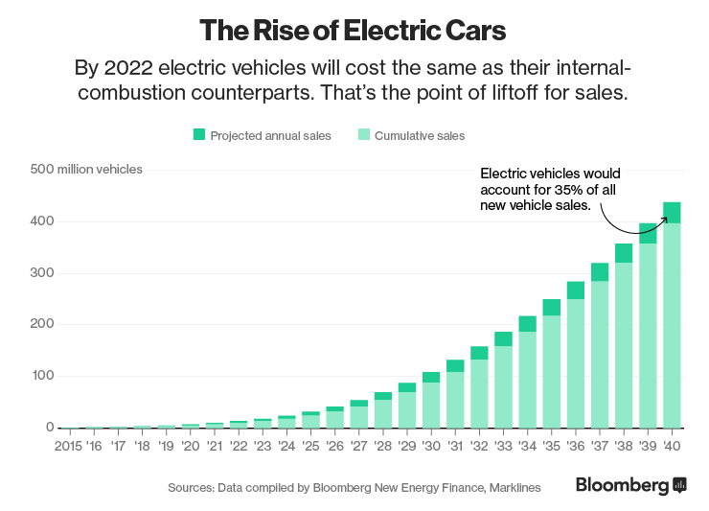

Figure 1 Prediction as to how the demand for electric cars is expected to boom in the coming decades.

This intrinsic dependence upon fossil fuels may no longer be a suitable option for the industry as world reserves are depleting at a rapid unsustainable rate. Some predictions estimate that as early as 2042 the world’s crude oil reservoirs will deplete leaving many automotive vehicles without any power (Shafiee and Topal, 2009). In attempt to forestall and avoid the consequences of this crisis, many automotive companies have begun developing sustainable vehicles which are independent of fossil fuels. Electrically driven vehicles have emerged as the most suitable replacements for petrol cars and almost all automotive firms currently manufacture a commercial EDV or are in the process of developing one for public use. By using electric power instead of fuel, the vehicle’s carbon dioxide emissions reduce drastically, in the case of the Tesla Roadster the CO2 levels are roughly 3.6 times less than the typical natural gas engine (Eberhard and Tarpenning, 2006). At this rate of EDV development Bloomberg New Energy Finance predicts that by 2040, more than a third of new production cars will be electric (Randall, 2016).

The first mass-produced commercial vehicle that utilised electric batteries was the Toyota Prius, which was released in 1997. The Prius’ design was a hybrid vehicle making use of both electric battery cells and gasoline as power sources for motion. The design was initially met with complaints regarding aesthetics and spaciousness, however, later models addressed this and the car became one of the most successful vehicles in history (Halbright and Dunn, 2010). The next step was mass-producing fully electric vehicles, which Tesla accomplished in 2006, by introducing the Tesla Roadster which ran on an AC induction motor using lithium ion battery cells. This car was the first commercially marketed and mass produced fully electric vehicle but was more of a novelty than a practical car for the public.

### Current Problems Facing the EDV Industry

Most of the current obstacles facing EDV development are attributed to the properties of the battery cells used, these include mileage, cycle life, charging time, safety and reliability (Deng et al., 2018). Of the currently available batteries, the one with greatest potential for success is the lithium-ion (Li-ion) battery which outperforms the others with regards to specific energy, specific power, cell voltage and self-discharge rate, see Table 1 (Liu et al., 2017).

Table 1 Properties of different electric vehicle batteries (Liu et al., 2017)

|  |  |  |  |  |  |
| --- | --- | --- | --- | --- | --- |
| Type | Specific Energy (Wh/kg) | Specific Power (kW/kg) | Nominal Cell Voltage (V) | Life cycles | Self-discharge rate (%) |
| Lead-acid | 25-40 | 150-250 | 2 | 200-700 | 5 |
| Nickel-iron | 50 | 100 | 1.2 | 2000 | 20-40 |
| Li-ion | 110-180 | 300 | 3.6 | >1000 | 10 |

However, one of the biggest challenges associated with Li-ion power is that the operating temperature range is very narrow and there are significant safety risks that appear when functioning outside this range. When temperatures exceed 80°C thermal runway becomes a concern, as it causes harmful gas emissions, smoke, fires and possible explosions (Deng et al., 2018). Furthermore, when the temperature gradient is outside 5°C there are detrimental effects on battery longevity and exacerbated degradation of the cells (Worwood et al., 2017).

The heat generated within the cells is a function of the charging and discharging processes and these impact the batteries’ capabilities, reducing these rates would solve some issues but limit the maximum power output. As such, one of the main focuses of EDV research is the development of thermal management systems to aid in cooling the battery cells to within the optimal range. This helps overcome the safety and longevity concerns while drastically improving performance and simultaneously maintaining the same level of power output.

## Aims and Objectives

The aim of this project is to investigate the effectiveness of different thermal management systems, and to compare their performances to find an optimal solution for EDV. The project will develop a numerical model to represent an EDV Li-ion battery in 2 dimensions, in an unsteady state. The code should model the thermal dissipation over time and represent the time dependent behavior of the battery.

Objectives:

* Find an optimal operating setup which reduces the temperature gradient while also allowing for a high-power output
* Provide context for how the optimal setup will improve performance (i.e. effect on maximum power output, battery life and possibly charging/discharging speeds)
* Make a reasonable supported conclusion as to which optimum cooling system the electric car industry should adopt moving forward.

## Research Questions

_ To what extent does the use of battery thermal management systems affect the heat distribution within the cell and how does this affect the battery’s performance levels.

_ How can the modification of certain cooling systems parameters improve effectiveness?

_ How can an optimal solution be constructed which provides the greatest cooling while maintaining an even temperature gradient?

## Project Impact

The work undertaken in this project will be of benefit to the electric driven automotive industry, as it will present evidence as to how to optimise the thermal management system of battery cells in their vehicles. This information will help in optimising the power performance and longevity of the EDVs produced.

The research will benefit the environment as it potentially will reduce the likelihood of thermal runway, which will lead to reduced greenhouse emissions and a more sustainable mode of transport. Additionally, by helping to design the cooling system effectively the research will possibly increase EDV production and help outnumber the traditional environmentally unfriendly vehicles on the road.

The research will also benefit society in that the improvements in longevity will increase the appeal of electric vehicles to consumers who were hesitant to purchase the vehicles because of their shortcomings. Society will also benefit through the increased safety that comes with the effective cooling, as the chance of battery overheating, or explosion will be reduced.

# Methodology and Research Design

## Data Collection and Analysis

A numerical model is used to simulate the temperature changes in a Li-Ion battery, this model is governed by the heat conduction equation. Although the model is based on the fundamental heat equation it does not completely replicate the cell in reality. However, research conducted through experimentation is much more time consuming and susceptible to errors, therefore, numerical simulation provides a suitable alternative, particularly if the model is validated using experimental data. Additionally, the computational model allows for easy changes in input parameters and initial conditions such as ambient temperature which are much more difficult to control in reality. Overall, the model provides sufficiently accurate data while also being efficient and simple to utilise.

## Description of Methodology

*\*Note: At the current stage of the project the numerical model is simplified into a steady state problem therefore the assumption is made that dT/dt = 0. Also, at this stage the code only represents heat distribution and does not calculate heat transfer rate, this will be addressed in the following section of the project.*

**Regarding MATLAB code (Appendix 1):**

* The following set of assumptions are made about the battery and the thermodynamics involved in order to simplify the modeling process:
  1. Heat generation is entirely electrothermal, chemical reactions are represented through resistors.
  2. Assume no degradation through one cycle of charging and discharging
  3. Thermal pattern does not vary in the z-direction (only in x and y direction)
* Develop a code to represent the Li-Ion battery as a set of nodes representing temperature
* Add in boundary conditions to the model to replicate the battery and its positive and negative tabs, (see Figure 1):
  1. Constant heat transfer rate at both tabs
  2. Heat loss from left, bottom and right sides as well as gaps on the top edge
  3. Internal domain has an additional heat generated term
* Develop a model for the thermal dissipation over time and write code to represent the time dependent behavior of the battery
* Run a mesh convergence test in order to ensure grid independence as well as ensure appropriate use of computing power.
* Convert heat flux into cell face value temperatures then convert into graphic representation (i.e. colored heat distribution plots)
* Use ANSYS/Fluent to model the same geometry and consider the difference in results

Figure 2 Illustration of Li-ion battery boundary conditions in 2 dimensions

**Regarding the Battery Thermal Management System:**

* Change the voltage and current and examine the effect of changing these parameters with regards to heat distribution
* Consider active cooling setups which utilize a range of cooling fluids (air, refrigerant, water)
* Consider passive cooling using heat pipes and phase changing materials and examine how each affects the thermal distribution in the battery.
* Consider different cooling setups including combinations of two cooling kits
* Find an optimal operating setup which reduces the temperature gradient while also allowing for a high-power output

## Numerical Simulation Theory

In order to create the 2D simulation for this project, certain fundamental equations of heat transfer must be used among with numerical modelling analysis.

### Modelling and Simulation Theory

In order to solve for the temperature at any point in the battery, the area must be split up into discrete cells and nodes. Depending on what nodal resolution is defined, the number of cells will increase or decrease. For this model $i$ nodes are set in the x-domain and $j$ nodes are set in the y-domain. Once the number of cells is properly defined a cell spatial discretization method must be used in order to solve for the values of each cell. Because the heat transfer equations include a Laplacian function, with second derivates of temperature $φ$ in both x and y directions, a finite difference equation can be used to approximate the second order derivatives. This can be derived from an expansion of the Taylor Series and produces equations (1) and (2), when using a 3-point stencil (Jabbari, 2019).

$\frac{∂^{2}φ_{i,j}}{∂x^{2}}≈\frac{1}{h^{2}}(φ_{i+1,j}-2φ_{i,j}+φ_{i-1,j})$ (Eqn.1)

$\frac{∂^{2}φ_{i,j}}{∂y^{2}}≈\frac{1}{h^{2}}(φ_{i,j+1}-2φ_{i,j}+φ_{i,j-1})$ (Eqn.2)

$∇^{2}φ_{i,j}=\frac{∂^{2}φ_{i,j}}{∂x^{2}}+\frac{∂^{2}φ_{i,j}}{∂y^{2}}=\frac{1}{h^{2}}(φ_{i+1,j}+φ_{i-1,j }{+ φ}_{i,j+1}+φ_{i,j-1}-4φ_{i,j})$ (Eqn.3)

Because of the 2-dimensional nature of the problem a 5-point stencil including centre point, and two neighbouring points in both x and y directions is used (Jabbari, 2019). The Laplacian condition (Eqn.3) then applies at all points except those which are on the boundaries as some of the terms in the equation will not exist.

For these boundaries a Neumann boundary condition is applied, where the value of the cells on the boundary are assigned a partial derivative value representative of the temperature gradient along said boundary. Through manipulation of the central difference scheme and the Laplacian condition, the sides of the battery can be solved for and similar governing equations can be produced.

Table 2 illustrates the conditions set for the initial part of this investigation. The positive and negative tabs are assigned constant temperatures of 50°C representing the heat flux into the battery. On the other hand, all boundary conditions other than the tabs are assigned constant ambient temperature values of 25°C for simplicity. At the moment the corners of the grid are solved for by averaging the two cells either side of it.

Table 2 Finite Difference Equations for a grid of 50x50 nodes for initial stage of project

|  |  |  |  |
| --- | --- | --- | --- |
| Location | i | j | Finite Difference Equations |
| Internal domain | 2:49 | 2:49 | $$\frac{1}{h^{2}}(φ_{i+1,j}+φ_{i-1,j }{+ φ}_{i,j+1}+φ_{i,j-1}-4φ_{i,j})$$ |
| Positive tab | 11:20 | 1 | $$φ_{i,j}=50$$ |
| Negative tab | 31:40 | 1 | $$φ_{i,j}=50$$ |
| Remaining Perimeter | - | - | $$φ_{i,j}=25$$ |

### Heat Transfer Theory

The governing equation for the heat transfer in the battery cell is the heat conduction equation also known as the Fourier-Biot Equation:

$ρc_{p}\frac{∂T}{∂t}=k\left[\frac{∂^{2}T}{∂x^{2}}+\frac{∂^{2}T}{∂y^{2}}\right]+{\dot{Q}}^{''}(t)$ (Eqn.4)

Where: $ρ$ is density kg/m3, is specific heat capacity J/kgK, $k$ is material conductivity (W/mK) and ${\dot{Q}}^{''}$ is internal heat generation (W/m3).

For the initial work of this project the $\frac{∂T}{∂t}$ term is nulled, indicating a steady state problem. However, in future work the internal heat generated will be a function of the current of the battery which will vary over time in a cyclic manner, leading to a time dependent temperature distribution.

The other governing equation is heat convection equation (i.e. Newton’s Law of cooling):

$q=h(T-T_{∞})$ (Eqn.5)

Where: $q$ is heat transfer per unit area (W/m2), is convective heat transfer coefficient (W/m2K), and is the freestream temperature of the cooling fluid (K).

The $T$ value is the temperature of the boundary of the battery just before it comes in contact with the cooling fluid, in this project these are the points with i or j values of 1 or res.

Essentially the greater the temperature difference the greater the heat transfer rate away from the battery. Equation 4 can only be used with the air and liquid systems, which allow for convection and heat transfer away from the battery. In this project Equation 5 will be used to quantify how much heat is transferred away from the system with each BTMS and allows for a quantitative comparison between systems.

## Literature Review

### Current Context of Project

There are currently two fundamental issues that the electric vehicle must overcome in order to attain top performances. Firstly, there are functionality concerns; overheating of the power cells is commonplace and so is shortage of battery life. Secondly, there are also significant safety concerns; thermal runaway regularly happens, and battery explosions are rare but pose a deadly risk to the public (Liu et al., 2019).

Because of the thermal context of these concerns, Li-ion battery manufacturers often quote optimal/safe operating temperatures such as to minimize the risk of the aforementioned concerns. The window of recommended operating temperatures for most automotive batteries varies between each manufacturer but also varies between the different stages of the battery cycle: for discharging, -20 to 55°C, and for charging, 0 to 45°C (Lu et al., 2013). The operating voltage is also kept to a limit of 1.5 – 4.2 V such as to improve reliability (Lu et al., 2013). It is also required that the temperature gradient within a single cell not exceed 5°C as this causes the cell to perform as if it was at higher temperatures than it truly is, this leads to shorter cell life as well damaging the cell structure (Worwood et al., 2017).

These temperature ranges are often hard to maintain while attempting to extract as much energy as possible from the batteries. As such, there has been an abundance of research conducted to investigate the use of thermal management systems that allow for maximum power production while keeping the batteries within an optimal/safe window. These BTM systems have three main tasks (Lu et al., 2013):

1. *Protect the cells and battery packs from being damaged*
2. *Make the batteries operate within the proper voltage and temperature interval, guarantee the safety and prolong their service life as long as possible.*
3. *Maintain the batteries to operate in a state that the batteries could fulfil the vehicles' requirements.*

The thermal management systems that will be investigated in this report will be assessed with regards to how well they accomplish these three tasks.

### Description of Current Thermal Management Systems

#### Liquid Cooling

Liquid cooling involves using a coolant tank, a radiator and a pump. The system must be connected such that liquid can travel through the radiator and back to the tank. The radiator is positioned near the battery surface such that the heat transfer rate can be maximised. The pump increases the volume flow rate allowing for even larger heat transfer.

Liquid cooling is effective in that it uses a liquid medium, such as water, which has a very high thermal conductivity and specific heat capacity allowing for great temperature reductions at the battery surface (Deng et al., 2018).

However, liquid cooling systems are heavy and take up a lot of space, which is not ideal for commercial use. They also require additional power in order to activate the pumping mechanism, this power is referred to as parasitic power.

According to research by Hunan University, the liquid cooling system can be optimised using a graphite plate between the battery cell and the radiator pipes, this reduces the temperature difference from 7°C to 2°C (Deng et al., 2018). This is explained by the extremely high thermal conductivity of the graphite plate effectively improving the heat transfer efficiency of the system and increasing the direct contact area between the battery and the radiator pipes. The university concludes that Novec 7000 cooling fluid is promising as it absorbs large amounts of heat during its boiling process, but because of the availability of water and oil and their low costs, these are the most promising for industry (Deng et al., 2018).

#### Air Cooling

In automotive air cooling, the motion of the car through the air in the atmosphere is used to transfer heat away from the battery. It can be viewed from the perspective that the car is stationary, and that air flow is incoming at a velocity equal to the speed of the car. Channels are built into the structure of the car to allow for air flow to reach the batteries and be exhausted out to the atmosphere.

This system is very lightweight and cost-effective as it does not require the machining or manufacturing of complex structures. It also utilises the motion of the vehicle as the method for forcing convection meaning that parasitic power is kept to a minimum.

On the downside, the air medium has a very low thermal conductivity and low specific heat capacity, so it has a limited cooling performance (Deng et al., 2018).

In a paper comparing BTM systems, by Beijing Jiaotong University, air cooling was used in a cooling loop similar to the liquid cooling setup and it was found that with air much more power was needed to control the maximum temperature than with liquid and jacket cooling (Chen et al., 2016). The paper concluded that because of its high parasitic power consumption and low heat transfer rates, air is not an effective BTMS. However, freestream air cooling was not considered, this would remove any need for parasitic power it would also improve cooling as the air is not recycled so there is continuous influx of cool air.

#### Heat Pipes

Heat pipes are split into three sections, an evaporator and a condenser with an adiabatic section in-between. In the evaporator heat radiated from the battery is absorbed by fluid in the saturated state, this heat is then transferred to the condenser where the heat is lost to a cooling fluid. The fluid is then pulled back to the evaporator through capillary forces and the cycle repeats with heat being transferred away from the battery.

The advantage of using heat pipes is that they are generally lightweight, compact and have flexible geometries (Deng et al., 2018). Furthermore, heat pipes make use of temperature gradients in order to transfer heat, therefore an external power supply is not needed.

The disadvantage of the heat pipes is that they superimpose a temperature gradient onto the battery, meaning some regions will be of much higher temperature than others which can severely reduce battery lifespan. Furthermore, they require very low coolant temperatures in order to efficiently transport heat away from the cell.

In a paper by Warwick Manufacturing Group, heat pipes were investigated in a setup where a heat pipe was fitted concentrically within a cylindrical battery. The idea was that in this configuration the imposed temperature gradient can be avoided. However, they concluded that by adding the heat pipes, there was a 5.8% decrease in energy density of the cell and an 11.7% increase in the cell mass (Worwood et al., 2017). Furthermore, they noted that in order to increase to heat transfer rates to an adequate level, forced convection or liquid cooling is required at the base of the heat pipe.

#### Phase Change Material

The idea behind using phase changing materials (PCM) is that they absorb the latent heat produced by the battery and thus transfers the heat away from the cell itself. The material melts when heat is being produced by the battery and freezes back into solid during the off periods. Essentially, the PCM acts as a heat sink during the battery operation and during inactivity it serves as a heat source.

Common PCMs are paraffin waxes and hydrated salts both of which provide moderate to large energy storage densities. The two main advantages of the PCM structures is that they are lightweight, and they do not require additional power.

However, the PCMs exhibit very low thermal conductivities which means that a very large surface area is required for effective heat transfer. Also, the PCM system presents design engineers with a difficult encapsulation situation as the materials often do not conform to the available geometry (Farid et al., 2004). Furthermore, during idle/standby the PCM releases energy back to the batteries increasing their temperatures offsetting their main purpose.

In work done by Guangdong University of Technology, a pure PCM model was tested and it was found that with this model the temperature gradient can be consistently maintained under 2°C even at 3C discharge rates (Wu et al., 2017). However, they also found that on its own the PCM cannot keep the temperature within the safe window for prolonged periods of time. To overcome this a combination of a liquid cooling system and a PCM system was used and it was found that this combination kept the temperature under 50°C for more than 25,000 seconds whereas the pure PCM exceeded 50°C at around 10,000 seconds. Furthermore, by the 25,000 second mark the pure PCM temperature exceeded 75°C, which would have undoubtedly lead to thermal runaway (Wu et al., 2017).

### Gaps in Literature

After reviewing the current literature available related to the project, a few topics and explorations appear to be lacking, this section addresses these gaps.

* **Effects of tab cooling**
  + By cooling the positive and negative tabs the heat flux into the cell volume is likely to be reduced which would mean that the total heat is decreased. Some research has been conducted with regards to tab dimension optimisation in order to improve safety (Mei et al., 2018), but work done regarding system implementation at the tabs is sparse.
* **Alternative cooling fluids**
  + Research concerning oil as a cooling fluid for batteries is sparse, mainly because of its very high viscosity, if this problem is addressed it may be the future of BTM systems(Deng et al., 2018). By adding nanoparticles or liquid metal into coolant flows the thermal conductivity of the system is significantly increased. This would maintain relatively the same weight but would allow for greater heat transfer away from the battery.
* **Influence of vehicle velocity on cooling rates**
  + In traditional petrol-powered vehicles there is extensive research on how microchannels are used to cool the engine block and make use of the incoming air flow velocity. Most electric cars store their batteries at the rear of the car or the middle, to help with weight distribution, but at this point the air flow is significantly disturbed by the car body, so cooling would be erratic. It would be of greater benefit if the batteries are placed at front of the car such as to make use of the car’s velocity as a cooling system.
* **Effects of nearby cells on heat transfer**
  + For most work done in simulation the model only relates to one cell such as to simplify the numerical calculations. To account for this a heat transfer term is added to the boundary conditions. However, this assumption may not be valid for all batteries if some are cooled significantly more than others. Further research must be done to investigate the effects of the battery setup grid in order to reach more accurate conclusions.
* **Adjusting numerical model to resemble experimental reality**
  + The majority of research conducted establishes a numerical simulation from a series of governing thermodynamic equations and modelling formulas. However, no attempts are made to validate the codes being used or to incorporate real life performance characteristics into the model. This work will attempt to improve the model by accounting for the discrepancies between the simulation results and experimental results collected from previous years.

# Proposed Work

## Focus of this project

After consideration of the different approaches that could be taken with regards to the project direction it was decided that the most relevant/suitable direction would be to explore air cooling and phase change material systems as the optimal management systems.

This decision was based on the fact that with both systems there are a number of parameters which can be explored that would aid the battery performance. This will allow the project to investigate multiple input parameters and reach a conclusion as to how the process can be optimised. Furthermore, investigation into these systems will help explore some of the gaps in the available literature, making the project more useful to industrial applications.

Additionally, air cooling and PCM systems were selected because of their more beneficial characteristics which would likely provide a greater effectiveness and efficiency than the other BTM systems. Mainly, they utilise natural convection and conduction processes with no need for additional power supply apparatus, which simplifies the design system and reduces the weight of the BTMS.

On the other hand, heat pipes and liquid cooling are detrimental to cell life as they superimpose negative thermal gradients on the cell. Also, to achieve high effectiveness they require energy consuming parts, heat pipes need a cooled heat sink and liquid cooling needs a coolant pump. These systems increase weight and reduce power supply to the wheels, reducing power output.

## Initial work conducted

At the moment work has been done in order to establish a simple base code as a starting point for the full numerical model which will be used in the final report. The goal was to establish a model that could represent a 2-dimensional lithium-ion battery as a series of nodes which could model temperature distribution in a steady state.

### Stage 1

At this stage the code merely represents heat distribution with no internal heat generation term and no heat loss term across the boundaries. The temperature on the right left and bottom edges is set at ambient temperature of 20°C, and the temperature at the battery tabs is set at 50°C.

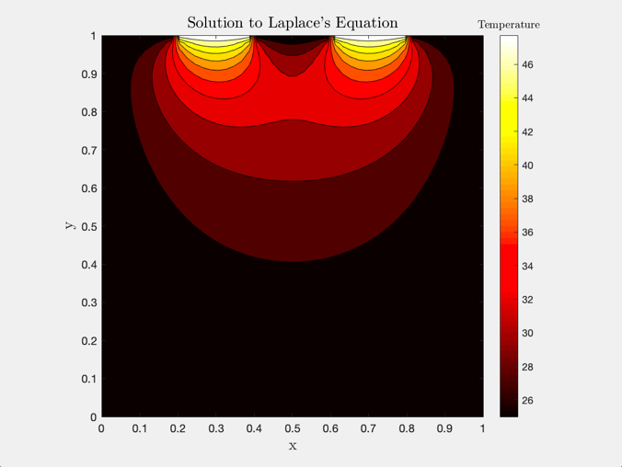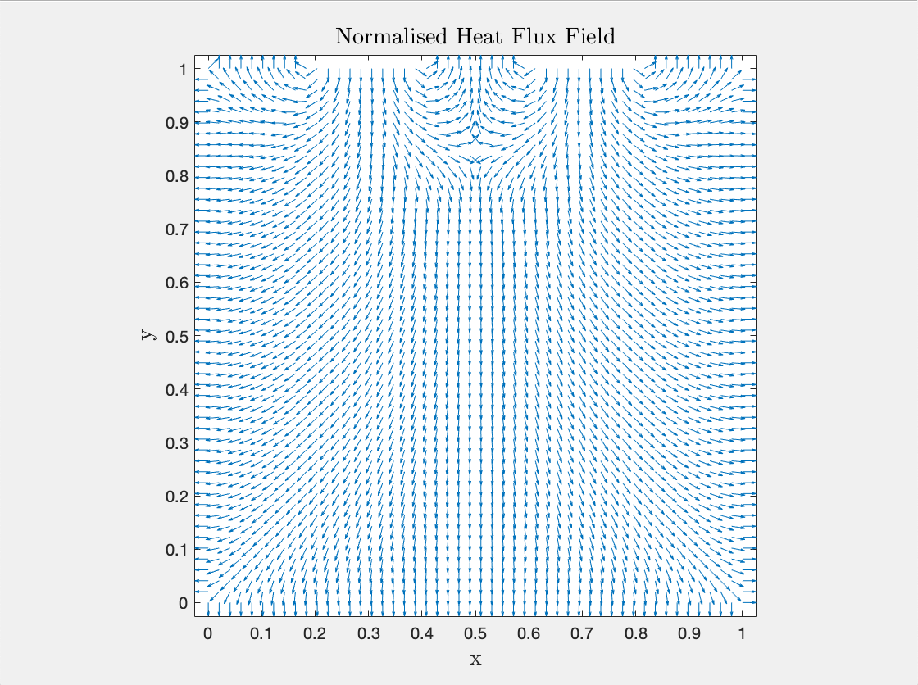 Figure 3a Thermal contour map illustrating temperature distribution and Figure 3b illustrates the heat flux field for Stage 1

### Stage 2

In this stage the internal heat generation term is accounted for and the internal domain nodes have a generated temperature of 50°C. The contour in Figure 4a is clearly different from 3a in that there are greater temperatures near the bottom edge of the cell. The corners and edges still remain relatively cold, which is an inaccurate representation.

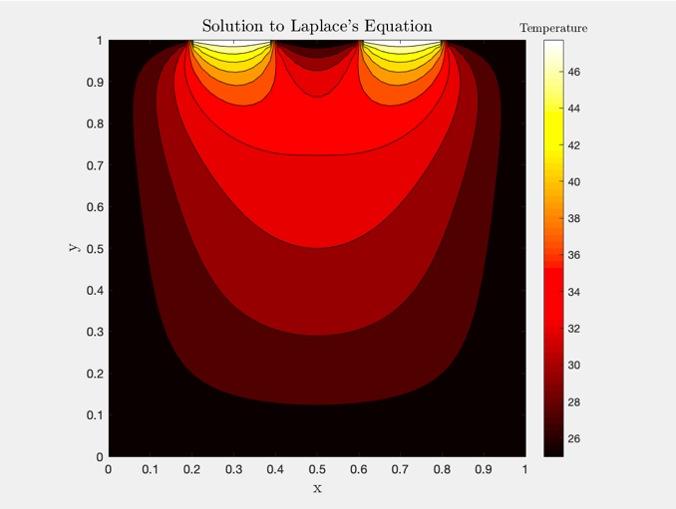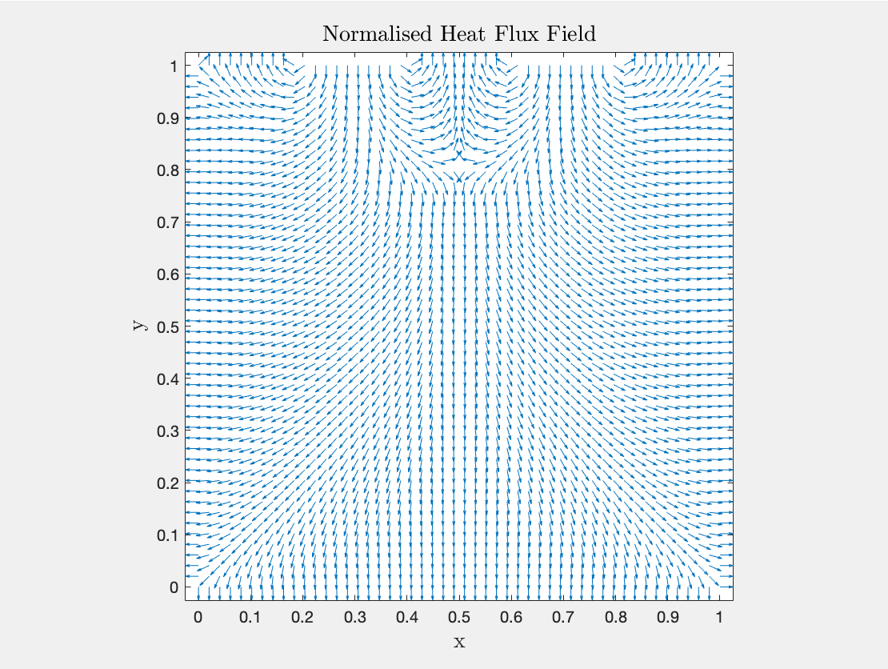

Figure 4a Thermal contour map illustrating temperature distribution and Figure 4b illustrates the heat flux field for Stage 2

### Stage 3 – Future Adjustments

At this stage Newton’s law of cooling will be applied in order to calculate an accurate temperature value for the boundary conditions not including the tabs. It is expected that a greater average temperature will be attained as imposing a constant heat transfer rate will cause the boundaries to be at a greater temperature than previously assumed ambient. The assumption of fixed ambient temperature is not realistic and major cooling would be required by the BTMS.

This stage will also be adapted such that the model would become unsteady. This will be done by adding a code as follows:

for t = 1 : time_final

...

b(ij) = f(t);

...

End

Here the f(t) will be a temperature as a function of time which will match the testing schedule illustrated in Figure 5, which is adapted from research done by the University of Waterloo (Chen, 2013). Then heat is generated by the battery during the charging section (80-120mins) and the temperature continues to rise until the resting section starts at the 120-minute mark. During the resting stage there is time for heat to be transferred away from the battery and the temperature to drop to cooler levels. It is expected that the greatest average temperature will be at the 120 min mark and the next highest would be at the 540 min marks after charging is complete.

Figure 5 Testing schedules for current(A) and heat flux (W) for li-ion battery examination (Chen, 2013)

### Model Validation

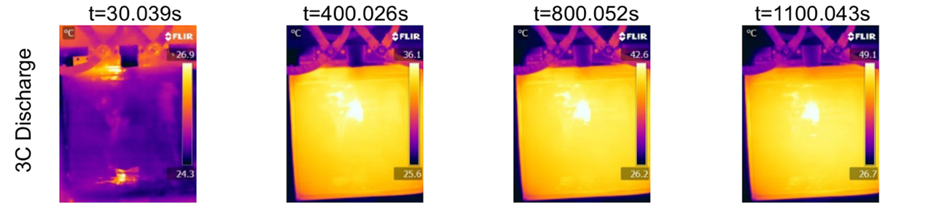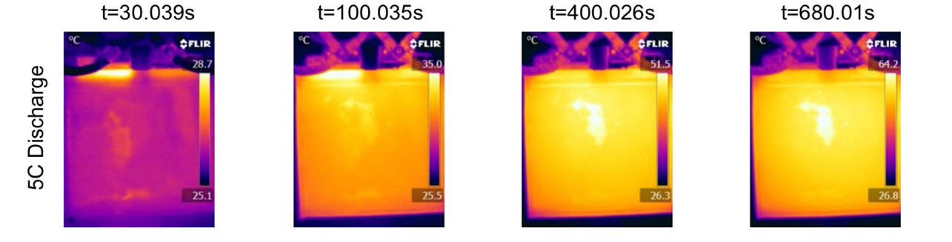

Figure 6 Temperature evolution of 53 Ah cell during a 3C discharge and a 5C discharge rates on (Hosseinzadeh et al., 2018)

After the numerical code is fully developed a model validation check will be conducted in order to confirm the accuracy of the model. To validate, thermal camera results from a study by WMG, University of Warwick, be compared to the contour plots produced in MATLAB for similar conditions (Hosseinzadeh et al., 2018), (see Figure 6). If there seems to be a standard error in the simulation, an attempt will be made to reduce this and have the results approach the true values.

At the moment the results produced are steady state, so the temperature evolution is not visible. However, once the time dependent term is added it is expected that the results will approach the experimental data, as the cooling will stabilise, and the temperature will be distributed in a similar manner.

# Management of Project to Date and Future Plan

## First Semester

## Second Semester

## Other courses’ deadlines

**MACE30051 Modelling & Simulation 3:** Lab on the 25th of November, due on 9th of December

**MACE30121 Manufacturing Engineering 3:** Due on 28th of November

**MACE31041 Design 3 (Mechanical):** Final Report due on 12th of December

**MACE30461 Operations Management:** Exam on 13th of December

This plan is set to begin on November 18th, any adjustments that will be made to the plan will be reflected in update reports throughout the project.

# Appendices

## Appendix 1: MATLAB Numerical model code

clear

close all

% FDM solver for Laplace's equation in 2D

% BCs: phi = qtab (right tab)

% phi = qtab (left tab)

% dphi/dx = 0 (left and right)

% dphi/dy = 0 (bottom and gaps on top)

%% Settings

% Resolution

res = 50; % ONLY MULTIPLES OF 10

rdfive = res/5;

% Length of domain

L = 1;

% Grid spacing

gs = L / (res - 1);

%% Battery and Thermal Characteristics

% Initial qin from tabs

qtab = 50;

% Initial Ambient Temp (C)

T_amb = 25;

% Internal Temp Generated

in_hg = 50;

% Heat transfer coefficient (W/Km^2)

h = 35;

%% Construct matrices

% Looking to construct linear system Ax = b

A = zeros(res * res);

phi = zeros(size(A, 1), 1);

b = zeros(size(phi));

% Populate the A matrix

for i = 1 : res

for j = 1 : res

% Get the position in the vector for unknown phi_ij

ij = getId(i, j, res);

% Top Right Corner

if (i == res && j == res)

% phi_ij - 0.5 * (phi_i-1j + phi_ij-1) = 0

% Get indices for the coefficients

im1j = getId(i-1, j, res);

ijm1 = getId(i, j-1, res);

% Add coefficients to the A matrix

A(ij, ij) = 1;

A(ij, im1j) = -0.5;

A(ij, ijm1) = -0.5;

% Top Left Corner

elseif (i == 1 && j == res)

% phi_ij - 0.5 * (phi_i+1j + phi_ij-1) = 0

% Get indices for the coefficients

ip1j = getId(i+1, j, res);

ijm1 = getId(i, j-1, res);

% Add coefficients to the A matrix

A(ij, ij) = 1;

A(ij, ip1j) = -0.5;

A(ij, ijm1) = -0.5;

% Right Edge and the Bottom Right Corner

elseif (j ~= res && i == res)

% phi_ij = T_amb

% Add coefficients to the A matrix and RHS

A(ij, ij) = 1;

b(ij) = T_amb;

% Left Edge and the Bottom Left Corner

elseif (j ~= res && i == 1)

% phi_ij = T_amb

% Add coefficients to the A matrix and RHS

A(ij, ij) = 1;

b(ij) = T_amb;

% Bottom Edge

elseif (j == 1 )

% phi_ij = 0

% Add coefficients to the A matrix and RHS

A(ij, ij) = 1;

b(ij) = T_amb;

% Top Edge

elseif (j == res )

% phi_ij = T_amb

% Add coefficients to the A matrix and RHS

A(ij, ij) = 1;

b(ij) = T_amb;

% Domain (inner nodes)

else

% 1/h^2 (ph_i+1j + ph_i-1j + phi_ij+1 + phi_ij-1 - 4 * phi_ij) = 0

% Get the Indices for the coefficients

ip1j = getId(i+1, j, res);

im1j = getId(i-1, j, res);

ijp1 = getId(i, j+1, res);

ijm1 = getId(i, j-1, res);

% Add coefficients to the A matrix

A(ij, ij) = -4 / gs^2;

A(ij, ip1j) = 1 / gs^2;

A(ij, im1j) = 1 / gs^2;

A(ij, ijp1) = 1 / gs^2;

A(ij, ijm1) = 1 / gs^2;

b(ij)=-in_hg;

end

% Left Tab

for LT = rdfive+1 : (2*rdfive)

if (j == res && i == LT)

% phi_ij = qtab

% Add coefficients to the A matrix and RHS

A(ij, ij) = 1;

b(ij) = qtab;

end

end

% Right Tab

for RT = (3*rdfive)+1 : (4*rdfive)

if (j == res && i == RT)

% phi_ij = qtab

% Add coefficients to the A matrix and RHS

A(ij, ij) = 1;

b(ij) = qtab;

end

end

% Empty Top Edges

for ETE = (2*rdfive)+1 : (3*rdfive)

if (j == res && i == ETE)

% phi_ij = T_amb

% Add coefficients to the A matrix and RHS

A(ij, ij) = 1;

b(ij) = T_amb;

end

end

end

end

%% Solve system

% Use direct solver in MATLAB

phi = A \ b;

% Reshape 1D results to 2D grid

phi2 = reshape(phi, res, res);

%% Plot results

% Create meshgrid of plotting points

[xplot, yplot] = meshgrid(linspace(0, L, res), linspace(0, L, res));

% Find Temp Gradient

[ux, uy] = gradient(phi2);

ux = -ux;

uy = -uy;

mag = sqrt(ux.^2 + uy.^2);

uxn = ux ./ mag;

uyn = uy ./ mag;

figure

quiver(xplot, yplot, uxn, uyn);

title('Normalised Heat Flux Field','interpreter','latex','Fontsize',14)

xlabel('x','interpreter','latex','Fontsize',14)

ylabel('y','interpreter','latex','Fontsize',14)

axis equal

axis tight

figure

contourf(xplot, yplot, phi2,10);

colorbar

colormap(hot)

title('Solution to Laplace''s Equation','interpreter','latex','Fontsize',14)

xlabel('x','interpreter','latex','Fontsize',14)

ylabel('y','interpreter','latex','Fontsize',14)

hcb=colorbar;

title(hcb,'Temperature','interpreter','latex','Fontsize',10)

view(2)

axis equal

axis tight

## Appendix 2: GetID function

function id = getID(i, n, N)

% getIdx: Returns the 1D index given a 2D index using base 1

id = i + N * (n-1);

## Appendix 3: MATLAB Testing Schedule code

% Test time length

tfinal = 540; %mins

time = 1:tfinal;

I = size(time);

% Relax stage

I(1:60) = 0;

% Discharge stage

I(61:120) = -20;

% Relax stage

I(121:240) = 0;

% Charge stage

I(241:tfinal) = 4;

% Internal Resistance (Ohms)

Rin = 0.37*10^-3;

% Heat Flux in at tabs

qtab=size(time);

for t=time

qtab(t)=Rin*(I(t))^2;

end

% Plot Current vs Time

figure

plot(time,I)

title('Current Test Schedule','interpreter','latex','Fontsize',14)

xlabel('Time (mins)','interpreter','latex','Fontsize',14)

ylabel('Current (A)','interpreter','latex','Fontsize',14)

% Plot Qin vs Time

figure

plot(time,qtab)

title('Heat in','interpreter','latex','Fontsize',14)

xlabel('Time (mins)','interpreter','latex','Fontsize',14)

ylabel('Heat flux (W)','interpreter','latex','Fontsize',14)

# Bibliography

Chen, D., Jiang, J., Kim, G.-H., Yang, C. & Pesaran, A. (2016). 'Comparison of different cooling methods for lithium ion battery cells', *Applied Thermal Engineering,* 94, pp. 846-854.

Chen, K. (2013). *Heat Generation Measurements of Prismatic Lithium Ion Batteries.* University of Waterloo

Deng, Y., Feng, C., Jiaqiang, E., Zhu, H., Chen, J., Wen, M. & Yin, H. (2018). 'Effects of different coolants and cooling strategies on the cooling performance of the power lithium ion battery system: A review', *Applied Thermal Engineering,* 142, pp. 10-29.

Eberhard, M. & Tarpenning, M. (2006). 'The 21 st century electric car tesla motors', *Tesla Motors*.

Farid, M. M., Khudhair, A. M., Razack, S. A. K. & Al-Hallaj, S. (2004). 'A review on phase change energy storage: materials and applications', *Energy conversion and management,* 45(9-10), pp. 1597-1615.

Halbright, R. & Dunn, M. (2010). 'Case Study: The Toyota Prius', *Managerial Marketing*.

Hosseinzadeh, E., Genieser, R., Worwood, D., Barai, A., Marco, J. & Jennings, P. (2018). 'A systematic approach for electrochemical-thermal modelling of a large format lithium-ion battery for electric vehicle application', *Journal of power sources,* 382, pp. 77-94.

Jabbari, M. (2019). CAE/CFD LECTURE 6 – MATLAB LIVE. University of Manchester.

Liu, B., Jia, Y., Yuan, C., Wang, L., Gao, X., Yin, S. & Xu, J. (2019). 'Safety issues and mechanisms of lithium-ion battery cell upon mechanical abusive loading: a review', *Energy Storage Materials*.

Liu, H., Wei, Z., He, W. & Zhao, J. (2017). 'Thermal issues about Li-ion batteries and recent progress in battery thermal management systems: A review', *Energy conversion and management,* 150, pp. 304-330.

Lu, L., Han, X., Li, J., Hua, J. & Ouyang, M. (2013). 'A review on the key issues for lithium-ion battery management in electric vehicles', *Journal of power sources,* 226, pp. 272-288.

Mei, W., Chen, H., Sun, J. & Wang, Q. (2018). 'Numerical study on tab dimension optimization of lithium-ion battery from the thermal safety perspective', *Applied Thermal Engineering,* 142, pp. 148-165.

Randall, T. (2016). 'Here’s how electric cars will cause the next oil crisis', *Bloomberg, New York, accessed Mar,* 25, p. 2016.

Shafiee, S. & Topal, E. (2009). 'When will fossil fuel reserves be diminished?', *Energy policy,* 37(1), pp. 181-189.

Smil, V. (2016). *Energy transitions: global and national perspectives*: ABC-CLIO.

Worwood, D., Kellner, Q., Wojtala, M., Widanage, W., McGlen, R., Greenwood, D. & Marco, J. (2017). 'A new approach to the internal thermal management of cylindrical battery cells for automotive applications', *Journal of Power Sources,* 346, pp. 151-166.

Wu, W., Yang, X., Zhang, G., Chen, K. & Wang, S. (2017). 'Experimental investigation on the thermal performance of heat pipe-assisted phase change material based battery thermal management system', *Energy Conversion and Management,* 138, pp. 486-492.